Quiz 2

Problem solving: Pseudo Code and flowcharts

- Write an Algorithm that will convert seconds to hour, minute and seconds.
  - 86399 seconds : 23 hours 59 minutes 59 seconds
- What will be output of the following flowchart if the following data is given as input:
  - Customer: John Age: 7
  - Customer: Peter Age: 65
  - Customer: Dave Age: 43
  - Complete the trace table given below for each iteration.

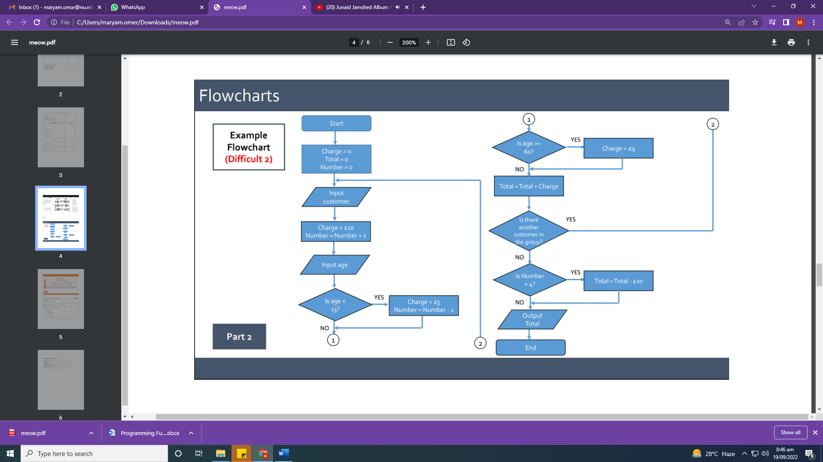

Charge | Total | Number | customer | age | charge | Total

